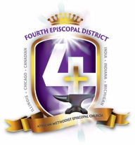 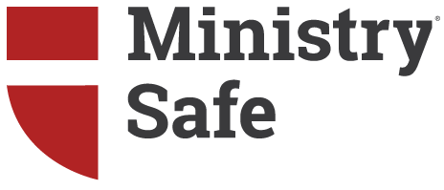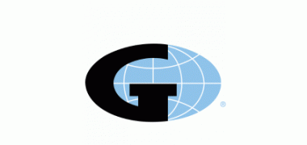

The Fourth District of the African Methodist Episcopal Church (AME) has partnered with MinistrySafe to provide a consistent and comprehensive sexual abuse prevention safety system.

It is the responsibility of each AME congregation to access its unique MinistrySafe online Control Panel and provide the online Sexual Abuse Awareness Training to all staff members and volunteers who work with children or vulnerable populations. In addition to training, there are other online resources available to each AME congregation – sample policy forms, screening forms, helpful articles and more.

MinistrySafe provides criminal background checks at a discounted rate to AME ministries. The online Sexual Abuse Awareness Training costs are covered by the District; the cost of criminal background checks is discounted, but paid by the congregation independently. Contact MinistrySafe for a discounted pricing list – contact info below.

Below are commonly asked questions about accessing and using the MinistrySafe system:

# How do I access and activate my account?

1. Go to MinistrySafe.com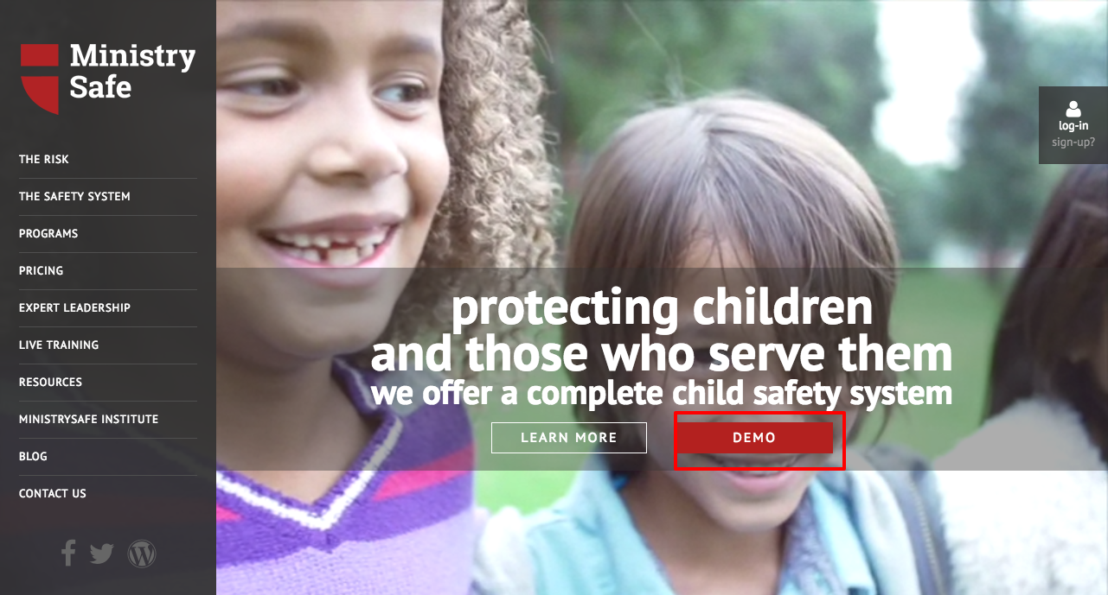
2. Watch the demo video from the link on the home page, then click log-in.

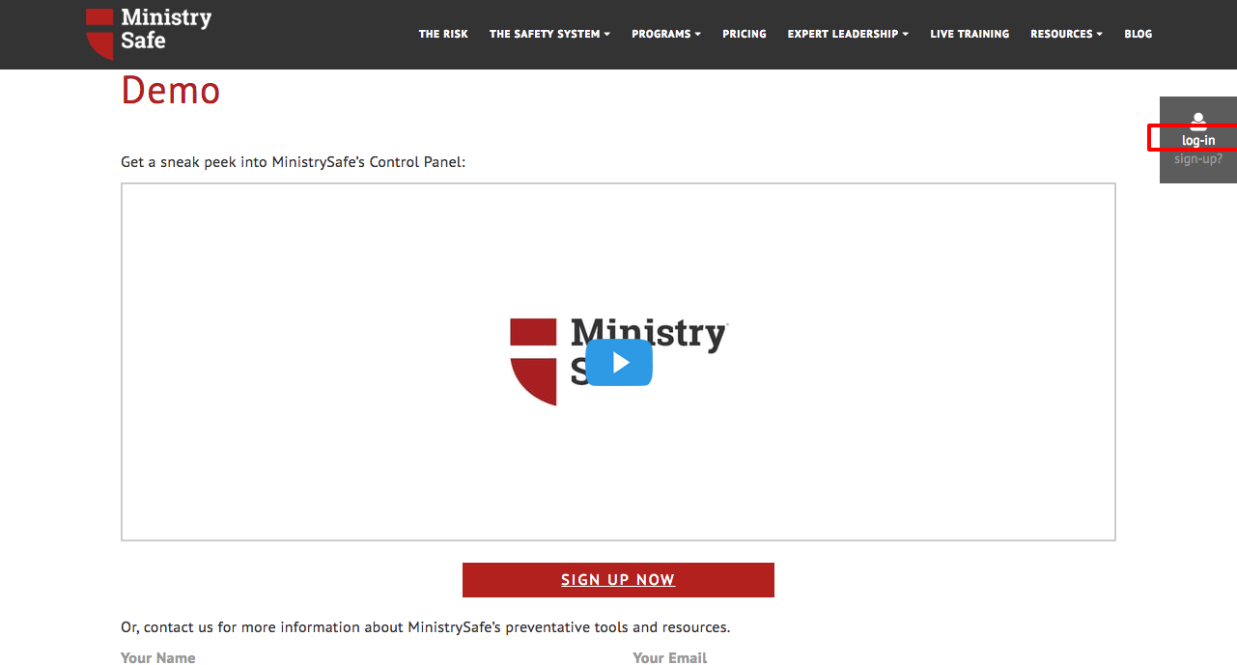

1. Log in using your username and password. You should have already received an email with your username and a link to set your password.

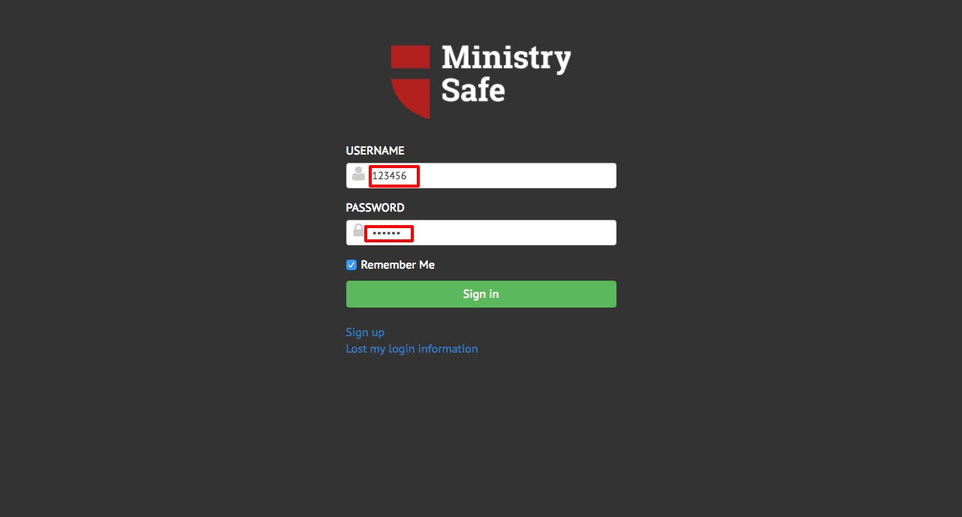

# 

# How do I set up my MinistrySafe Control Panel?

1. Enter trainees into the control panel

-Start by clicking “Add User” on the Manage Users page

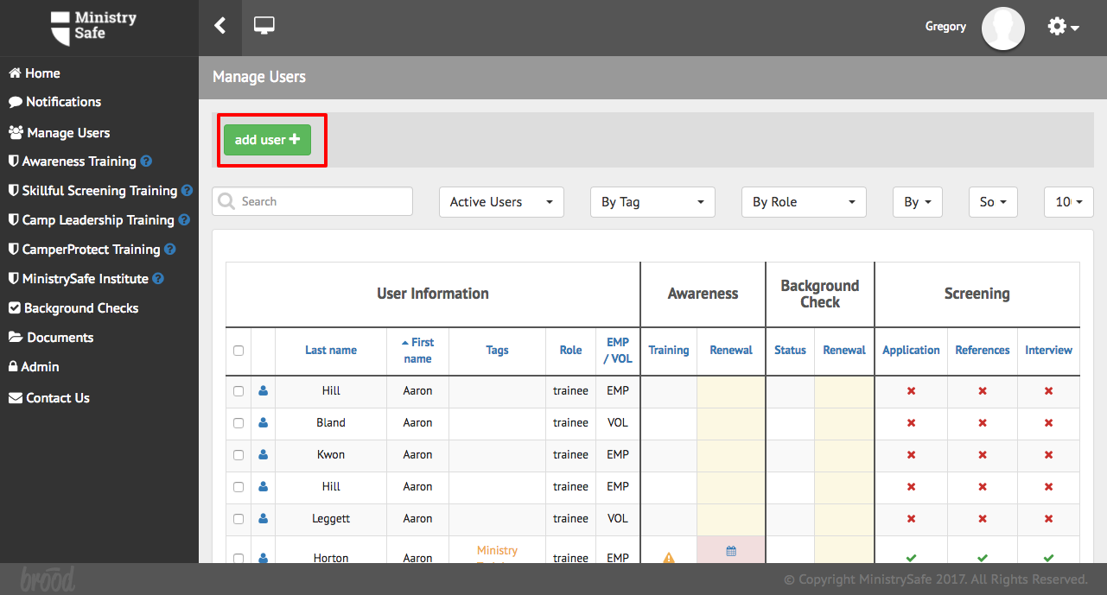

1. Enter the trainee’s information

-Enter the trainee’s name and email address.

-Select a tag and an Awareness Training to send

-Click “Add User” and repeat process for next trainee

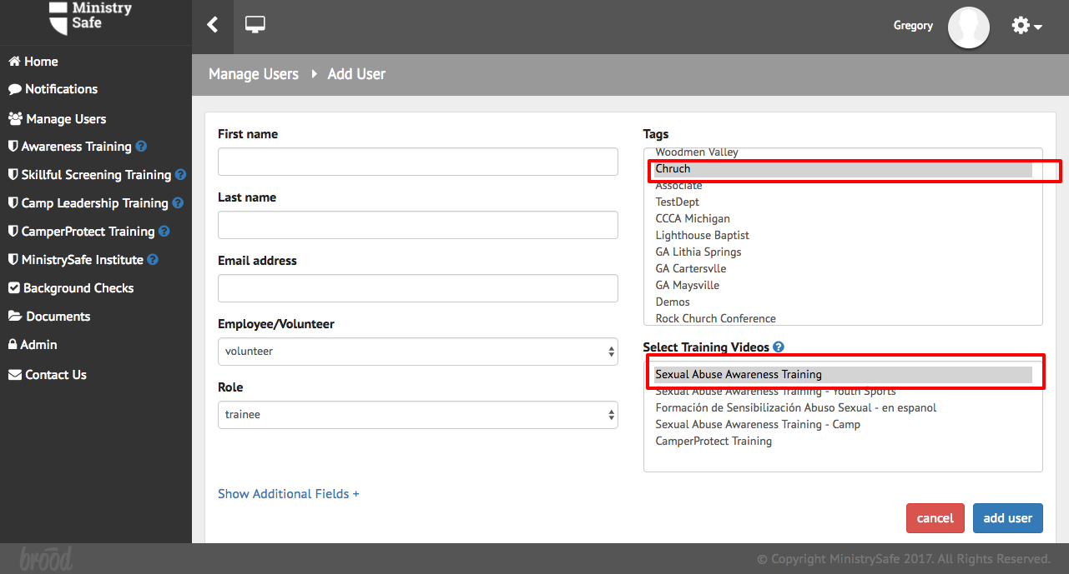

*If you have a large number (30+) of trainees to add, please contact MinistrySafe to begin the process of importing trainees through an import form. You will provide MinistrySafe with your trainee’s information in an Excel spreadsheet and MinistrySafe will import the trainees for you.

# What happens next?

Your job is finished!

MinistrySafe will automatically send an email to your trainee containing a link to the online training. Your trainee simply needs to click on the link in the email.

After clicking on the link, your trainee will be prompted to watch the Sexual Abuse Awareness Training, which is just over one hour in length. After watching the training, your trainee will be prompted to take a short quiz, which is scored online. A score of 70 or better will generate a Certificate of Completion.

Once your trainee has completed the quiz and received the Certificate of Completion, an email containing the Certificate of Completion will be sent to the trainee AND the Safety System Administrator and the trainee’s supervisor. The online Control Panel will also be updated to reflect the completion of the training and calculate the renewal date for the training.

If the training is not completed in a reasonable time period, check with your trainee to determine if there is a problem...or simply resend the training link.

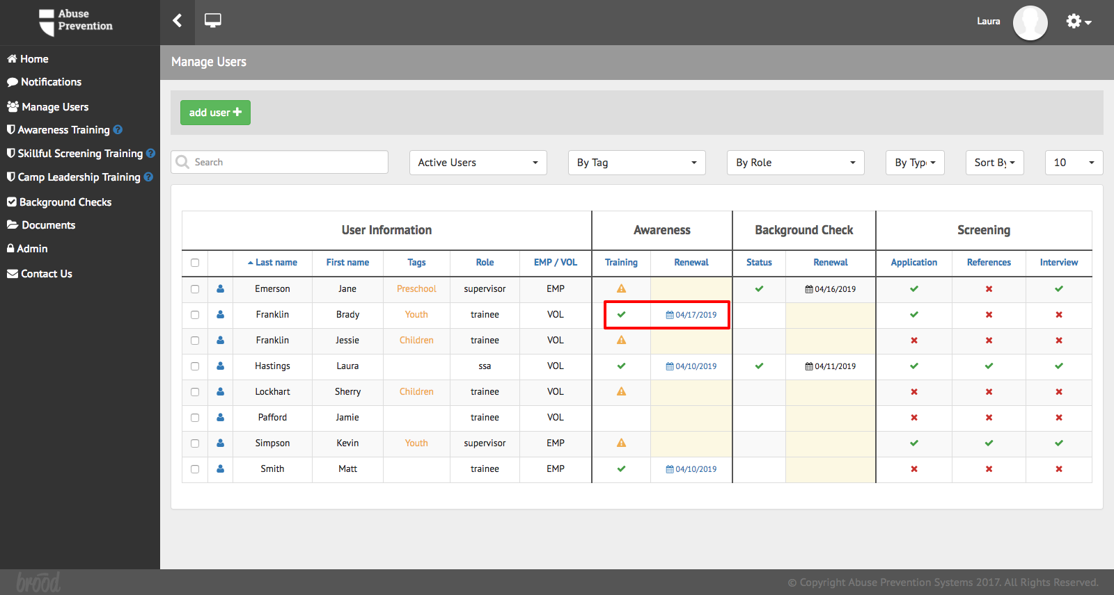

Where can I access other helpful resources?

* Free “Overview of a Safety System” videos at <https://ministrysafe.com/create-a-system/>
* MinistrySafe resources page: <https://ministrysafe.com/resources/>
* Members have full access to our resource library in the control panel, including policy and screening forms for churches, schools, camps and more.

Your most valuable resources are:

The MinistrySafe staff: ([support@ministrysafe.com](mailto:support@ministrysafe.com)) ( 817) 737-7233; or

The 4th District of the AME Church: Rev. Walter Bauldrick (revwrb@mdamec.org)

# Frequently asked questions:

Q – How much is this going to cost?

A – AME will cover the membership fee and online trainings for all AME member churches.

Q – How efficient is the email system?

A – Very efficient! MinistrySafe sends thousands of links per month and about 95% of them get to the trainee the first time. Mainstream providers like Gmail and Yahoo recognize MinistrySafe emails.

Q – Are there common reasons for not receiving the email?

A – Yes. Forgetting to select which Awareness Training to send and incorrect email addresses account for the majority of errors in receiving. However, because this is a child sexual abuse awareness training, some SPAM filters sort to junk mail or reject the email altogether.

Q – Can I send the link to any email address?

A – Yes. In fact, you can send the training links to your own email, a church email, or shared email address. You can even forward them; copy and paste the link; whatever you need to do. However, the training links are specific to one trainee and that trainee must use his or her own link.

# For more information please visit:

<https://ministrysafe.com/ame4/>