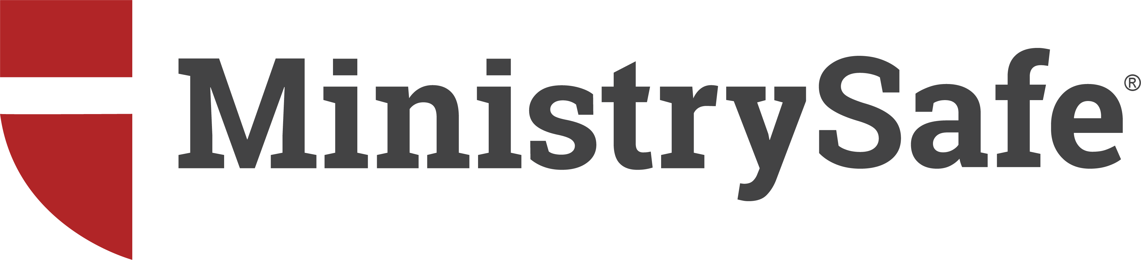

REPORTING CHILD ABUSE or NEGLECT

Last Updated: January 2, 2020

THE LAW
Every state in the United States has child abuse and neglect reporting law requiring that adults report suspected or alleged abuse, neglect, or maltreatment of a child. In some states, every adult is a mandated reporter. Other states list those adults who are required to report – usually by profession or licensure. It is our desire to be proactive in all matters relating to protection of young people.

Regardless of whether your state makes all adults mandated reporters, the best practice for organizations is to require all adults who wear your nametag (as volunteers or employees) to report suspicions of abuse or neglect to the appropriate child protection or criminal authorities. Legal requirements that ‘suspected’ abuse or neglect be reported are intentionally broad: when in doubt, REPORT.

DETERMINING YOUR REPORTING AUTHORITY
BEFORE encountering an allegation or reportable event, you should know when and to whom a report should be made. Accordingly, each organization must research and understand the reporting process for its jurisdiction, and this information must be documented and disseminated to staff members and volunteers. If your organization has multiple locations or campuses, this exercise must be completed for each location. If multiple locations are within the same county, it is likely that the entity to whom an organization should report will be the same.

Accessing State Reporting Laws
Start by accessing state reporting requirements as if you had information requiring a report. Using Madison, WI as an example, perform an online search for ‘child abuse reporting hotline Madison Wisconsin’. The first search result lists a county and tribe contact map for reporting within the state of Wisconsin. Click on the interactive map for contact information for reports in a specific county, including telephone numbers.

Call the provided number and confirm that you have reached the appropriate entity or agency for your location. Then ask the representative to describe the information needed to complete a report, and the appropriate process for making a report. (Example: time frame requirements, written vs. oral reports, ability to make reports online, etc.)

By the time this call(s) is completed, the caller should understand to whom to report, where to report, how to report and what to report.

Document Your Findings
After completing the process above, create a memo that documents your findings.
This memo should include:
-the hotline telephone number to call when making a report
-the web address or website, if an online reporting process is available*
-the process for reporting and required timelines (i.e., within 24 hours)
-a list of required or suggested information to be included in a report.

Note the name and position or title of the individual providing this information, and the date the information was provided. Update and confirm this information once each year, as reporting statutes are changing nationwide.

When completed, this memo, and all subsequent versions created yearly, should be forwarded to the organization’s administrative office. All employees and volunteers should be given a copy of the latest version of this memo to ensure that all staff members and volunteers understand current reporting requirements and organization policy related to reporting. The organization may also want to include internal reporting obligations and processes.

Making a Report
Include a reminder at the bottom of the memo reminding the reporter to create an Incident Report. The Incident Report should include:
-the name of the reporter
-the date, time and location of the report
-the information reported
-the person to whom the report was made, including title or position, and
-a file number or report confirmation number.

A copy of the Incident Report should be forwarded immediately to organizational leadership and ____________________________________.

Past Reportable Events
It is possible that this exercise will bring to light past events that should have been reported. It is never too late to do the right thing. Suspicions or allegations that should have been reported in the past SHOULD BE REPORTED NOW.

In the event a past reportable event arises, follow the process above and report to appropriate authorities. Once completed, immediately forward the Incident Report to organizational leadership.

REPORTING TO INSURANCE CARRIER
Keep in mind that some reportable matters should also be reported to the organization’s insurance carrier. When in doubt, seek legal guidance.

*Web-based reports should not be utilized if a child is in immediate danger or experiencing ongoing harm.

ALTERNATIVE PROCESS
Step-by-Step Guide to Locating Your State’s Reporting Requirements

- Go to www.childwelfare.gov.
- Click ‘State Resources’ on the blue menu near the top of the page.
- In the dropdown menu, click ‘State Statutes’.
- Select the state(s) you’d like to view.
- Select any topic you’d like to view. Suggested topics include:
  - Clergy as Mandatory Reporters of Child Abuse and Neglect
  - Definitions of Child Abuse and Neglect
  - Immunity for Reporters of Child Abuse and Neglect
  - Making and Screening Reports of Child Abuse and Neglect
  - Mandatory Reporters of Child Abuse and Neglect*
  - Penalties for Failure to Report and False Reporting of Child Abuse and Neglect

*Tip: The word ‘shall’ means must (required by law) and the word ‘may’ means optional (not required by law). When identifying mandatory reporters, any individual that ‘shall’ report abuse or suspicions of abuse is considered a mandatory reporter and thus required by law to report.

Check this database semi-regularly (every 6 months) to ensure that your ministry’s reporting procedures are current according to state law.

For questions related to interpreting and/or applying your state’s reporting requirements, visit our Legal Consultation page to learn more (including the fee schedule) about scheduling a telephone consultation with an attorney.

